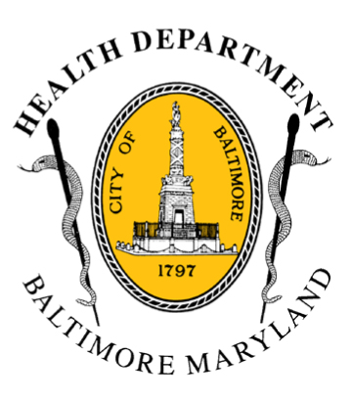
BCHD PRESS RELEASE
Baltimore City Health Department
1001 E. Fayette Street • Baltimore, Maryland 21202
Stephanie Rawlings-Blake, Mayor
Leana Wen, M.D., Commissioner of Health

FOR IMMEDIATE RELEASE

Media Contact: Michael Schwartzberg, PIO
O: (443) 984-2623 C: (443) 462-7939 E: michael.schwartzberg@baltimorecity.gov
Health Commissioner Declares Code Blue Alert
In Baltimore For Tuesday & Wednesday

BALTIMORE, MD (January 26, 2015) — With predicted low temperatures and wind chills for Tuesday and Wednesday in the teens, Leana Wen, M.D., Health Commissioner for Baltimore City, is declaring a Code Blue for January 27 & 28.

“The cold temperatures combined with the snow this week pose potentially life-threatening conditions for Baltimoreans,” Dr. Wen said. “We are particularly concerned about our most vulnerable residents, including the homeless, children, older adults, and people with chronic medical conditions.”

*Dr. Wen will be available today (Monday, January 26^{th)}, from 2 p.m. to 3:30 p.m. at the Health Department, 1001 E. Fayette Street, for media interested in interviews.*

This is the second Code Blue alert for Baltimore this season, the first was for January 7 – 9.

The Health Commissioner may declare a Code Blue alert when temperatures, including wind chill, are expected to be 13˚F or below or when other conditions are deemed by the Health Commissioner to be severe enough to present a substantial threat to the life or health of vulnerable Baltimore citizens.

Code Blue indicates an increased risk for cold injuries or even death for those exposed to low temperatures. Once a Code Blue declaration is made, public messaging activities are undertaken to encourage safety when outdoors and response partners work to ensure those in need find sheltering.

During a Code Blue, the Mayor’s Office of Human Services will continue to operate a 24-hour Housing & Resource Center for men and women at 620 Fallsway with 60 additional spaces available for residents seeking meals and sleeping quarters. Private homeless shelters will be encouraged to extend their hours and keep people indoors. In addition, all of Baltimore City's 13 senior centers will have free emergency meals available for clients.

- more-
2-2-2
Baltimore Code Blue Stats For Past Three Winters
Winter Season | Code Blue Days Declared | Hypothermia-Related Deaths
2013-14 | 34 | 4
2012-13 | 10 | 5
2011-12 | 11 | 3

Cold Weather Tips for Staying Healthy:
- Wear multiple layers of loose-fitting clothing.
- Always wear a head covering, like a hat and/or scarf, when outdoors.
- Drink plenty of fluids and avoid alcoholic beverages.
- Protect yourself against falls in icy or snowy conditions
- Check on those who are children, the elderly and/or chronically ill.
- Provide appropriate shelter for domestic animals.

Other Tips For Keeping Safe in Cold Weather:
- Keep space heaters and candles away from flammable materials, such as curtains, furniture and loose clothing.
- Check your carbon monoxide detector and make sure it’s working.
- Do not use prohibited heat or power sources, such as stoves or generators. They may cause fire or carbon monoxide poisoning.
- Do not leave your car running in a closed space such as a garage.

Residents are encouraged to contact 311 if a neighbor is without heat or power so that city agencies can assist them. Energy assistance may be available to those who need it. For more information, individuals may contact the Office of Home Energy Programs at 410-396-5555.

Additional cold-weather resources for the public including a listing of city and private shelters, is available on the Health Department’s website (http://health.baltimorecity.gov/). For other cold-related inquiries and service requests, or to find a nearby homeless shelter, residents can call 311 (410-396-3100 after hours).

“Extreme cold weather is just as dangerous as extreme hot weather,” said Dr. Wen. “We need to take extra care to protect ourselves and our loves ones, and also to look out for our neighbors and the most vulnerable among us. Keep warm and keep safe.”

###

